Edit the command clock settings
Right Click on the clock, and select "Digital Clock" Settings
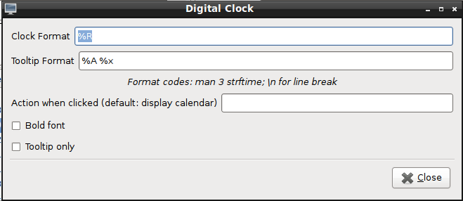
The default is %R which is the clock in 24 Hour Format, based on your local time-zone. To explain how adaptable it is, below are a couple of examples to get you started.
It is Friday the 16th July 2010, at 35 seconds past 22 minutes past 4 o'clock in the afternoon. It currently shows as 16:42 and you want it displayed as
- 04:22 PM
%I:%M %p
- Fri 16 Jul 10 04:22 PM
%a %d %b %y %I:%M %p
- 07-16-10 04:22:35 PM
%F %r
If you set up your time-zone up when you installed your system, then
%c
will give you your date and time with your localised settings.

Easy
For a Good Strftime is a website that builds your "time string" for you.

Advanced
These command strings also apply accross all the time and date systems for configuration across the *buntu system.
The entire list of what you can customise is
- %A is replaced by national representation of the full weekday name.
- %a is replaced by national representation of the abbreviated weekday name.
- %B is replaced by national representation of the full month name.
- %b is replaced by national representation of the abbreviated month name.
- %C is replaced by (year / 100) as decimal number; single digits are preceded by a zero.
- %c is replaced by national representation of time and date.
- %D is equivalent to %m/%d/%y.
- %d is replaced by the day of the month as a decimal number (01-31).
- %E* %O* POSIX locale extensions. The sequences %Ec %EC %Ex %EX %Ey %EY %Od %Oe %OH %OI %Om %OM %OS %Ou %OU %OV %Ow %OW %Oy are supposed to provide alternate representations. Additionly %OB implemented to represent alternative months names (used standalone, without day mentioned).
- %e is replaced by the day of month as a decimal number (1-31); single digits are preceded by a blank.
- %F is equivalent to %Y-%m-%d.
- %G is replaced by a year as a decimal number with century. This year is the one that contains the greater part of the week (Monday as the first day of the week).
- %g is replaced by the same year as in %G, but as a decimal number without century (00-99).
- %H is replaced by the hour (24-hour clock) as a decimal number (00-23).
- %h the same as %b.
- %I is replaced by the hour (12-hour clock) as a decimal number (01-12).
- %j is replaced by the day of the year as a decimal number (001-366).
- %k is replaced by the hour (24-hour clock) as a decimal number (0-23); single digits are preceded by a blank.
- %l is replaced by the hour (12-hour clock) as a decimal number (1-12); single digits are preceded by a blank.
- %M is replaced by the minute as a decimal number (00-59).
- %m is replaced by the month as a decimal number (01-12).
- %n is replaced by a newline.
- %O* the same as %E*.
- %p is replaced by national representation of either "ante meridiem" or "post meridiem" as appropriate.
- %R is equivalent to %H:%M.
- %r is equivalent to %I:%M:%S %p.
- %S is replaced by the second as a decimal number (00-60).
- %s is replaced by the number of seconds since the Epoch, UTC (see mktime(3)).
- %T is equivalent to %H:%M:%S.
- %t is replaced by a tab.
- %U is replaced by the week number of the year (Sunday as the first day of the week) as a decimal number (00-53).
- %u is replaced by the weekday (Monday as the first day of the week) as a decimal number (1-7).
- %V is replaced by the week number of the year (Monday as the first day of the week) as a decimal number (01-53). If the week containing January 1 has four or more days in the new year, then it is week 1; otherwise it is the last week of the previous year, and the next week is week 1.
- %v is equivalent to %e-%b-%Y.
- %W is replaced by the week number of the year (Monday as the first day of the week) as a decimal number (00-53).
- %w is replaced by the weekday (Sunday as the first day of the week) as a decimal number (0-6).
- %X is replaced by national representation of the time.
- %x is replaced by national representation of the date.
- %Y is replaced by the year with century as a decimal number.
- %y is replaced by the year without century as a decimal number (00-99).
- %Z is replaced by the time zone name.
- %z is replaced by the time zone offset from UTC; a leading plus sign stands for east of UTC, a minus sign for west of UTC, hours and minutes follow with two digits each and no delimiter between them (common form for RFC 822 date headers).
- %+ is replaced by national representation of the date and time (the format is similar to that produced by date(1)).
- %% is replaced by `%'.
From the examples above, you should be able to format the date / clock system to your own needs.

Time Zones
If you have friends scattered across time zones, I would suggest you add date and time to your bookmarks. You will see it used when giving a link for meetings etc.

Lubuntu/Documentation/CustomizingTheClock (last edited 2020-08-24 04:26:35 by guiverc)

